Title

name of authors ( teammates)

content

References

Internet Of Things 18CSE379T

**Automatic Bottle Filling Machines Using IoT**

Soumya Rathore [RA2011029010033], Shaleen Dubey [RA2011029010054]

***Abstract* - A distance sensor is an IoT device used in an automatic bottle-filling machine with a novelty which not only improves its functionality but also helps to achieve less wastage of resources inside the machine like any other liquid in it.**

**This project revolves around the idea of creating an Automatic System which not only senses but also measures the dimensions of the object in front of the machine using Smart Sensors and then sends a Sensor-Request to fill the liquid up to that proportions**

**Automatic Filling Machines have a vast use case, some of them include many offices and public places. Where people tend to use a coffee dispensing machine or water bottle filling machine which leads to wastage of the respective resources due to the machine’s lack of correct judgement as to when to stop filling.**

**This project uses not one but two Distance Sensors. One of which senses the distance of the object to be filled from the machine and the other measures the dimensions of the object which would be predefined by the machine, uses ultrasonic sensor HC-SR04.**

***Keywords:******Internet of Things (IoT), sensors, distance sensors, measurement of dimension, judgement, sensor request.***

1. Introduction

The working of the machine is basic and is implemented with the help of using two sensors as IoT devices. The principle on which it works is measuring the distance with the help of an ultrasonic pulse which is generated with the help of a sensor and object.

The working is based on the Distance formula, D = Speed*Time which helps in generating the distance between the object placed from the sensor.

It works when an object is placed near a particular distance either it generates a sound or shows a light depending upon what medium has been chosen to show the output.

The project explains the part when an object is placed at a predefined fixed place where a sensor measures the distance and sends the signal to start the water-filling process when it senses the accuracy between the object and machine.

Whereas on the other hand, the other sensor measures the height of the object to identify where the liquid has to be filled in order to not get it spilled and reduce its wastage of it.

Based on sensor information the decision is made and actuators start working which works by filling the water through machines to the object placed in front of it.

The information processed by the sensor to the machine is kept in an Arduino app which shows the establishment of a connection between the object and the machine.

There are a few predefined parameters set such as the distance between the object and the machine which tells how far and where it has been placed and the other information that the sensor stores are about the dimension of the bottle.

The data or information hence stored is then useful while giving the command to the actuator to move in a particular way to fill up to the specified dimension of the object.

Hence managing to waste fewer resources and optimise more of the machine.

Actuators help in moving the water filling inside the system in a particular linear direction which can change according to the height and dimension of the object and then proceed in letting out the liquid that is to be filled.

This project revolves around the idea of creating an Automatic System which not only senses but also measures the dimensions of the object in front of the machine using Smart Sensors and then sends a Sensor-Request to fill the liquid up to that proportion.

Automatic Filling Machines have a vast use case, some of them include many offices and public places. Where people tend to use a coffee dispensing machine or water bottle filling machine which leads to wastage of the respective resources due to the machine’s lack of correct judgement as to when to stop filling. To prevent that from happening, this project uses not one but two Distance Sensors. One of which senses the distance of the object to be filled from the machine and the other measures the dimensions of the object which would be predefined by the machine.

Sensors basically work on the data received and particular tasks as they are assigned to the distance sensor in particular tells about how far or close an object has been placed in order to work. It uses a few pre-defined parameters or data acquired from the sensors such as distances and heights of different object length width etc. for accurate decision-making in further process.

2. Literature Review

Our project uses the arduino model for the automatic bottle filling system and the automatic water-filling machine. [1] The sensor is used to detect the ultrasonic for measuring distance. It shows accuracy and error with the help of the ultrasonic principle, which is basically it captures the sound wave which is equal to or more than 20 kHz. (2020 ). [2] This consists of the transmitter part of ultrasonic module units. The distance from any object is calculated from D = S x T The ultrasonic module is initiated with a pulse of 10 us (2021 ). [3] It is compatible with many major simulation software like MATLAB and uses temperature compensation; it can be used over a wide temperature range. Height measurement can also be considered as another application. (2019 ). [4] The paper which tells us about the motion of the object was shown in this paper where it detects the movement of the objects and displays the results on the screen. It can either be on an LED display or any other device which shows the information about it and displays the result on it. It either records or it can either produce alarms as a display system. There can be different types of devices that can be used to detect the voice or noise of it such as piezo buzzer. It helps to produce sound at different levels of input received by the sensor.

It works by defining the range where it can work and produce sound beyond that range or minimum to that range it can not produce or show the output by producing sound.The distance greater or equal to the given range will be considered apart from this it would show no result. [5] We used the method of an ultrasonic sensor for distance measuring for example detecting the distance of an object how far or close it has been placed and giving information where the object is in live location (2020 ).

3. Proposed System

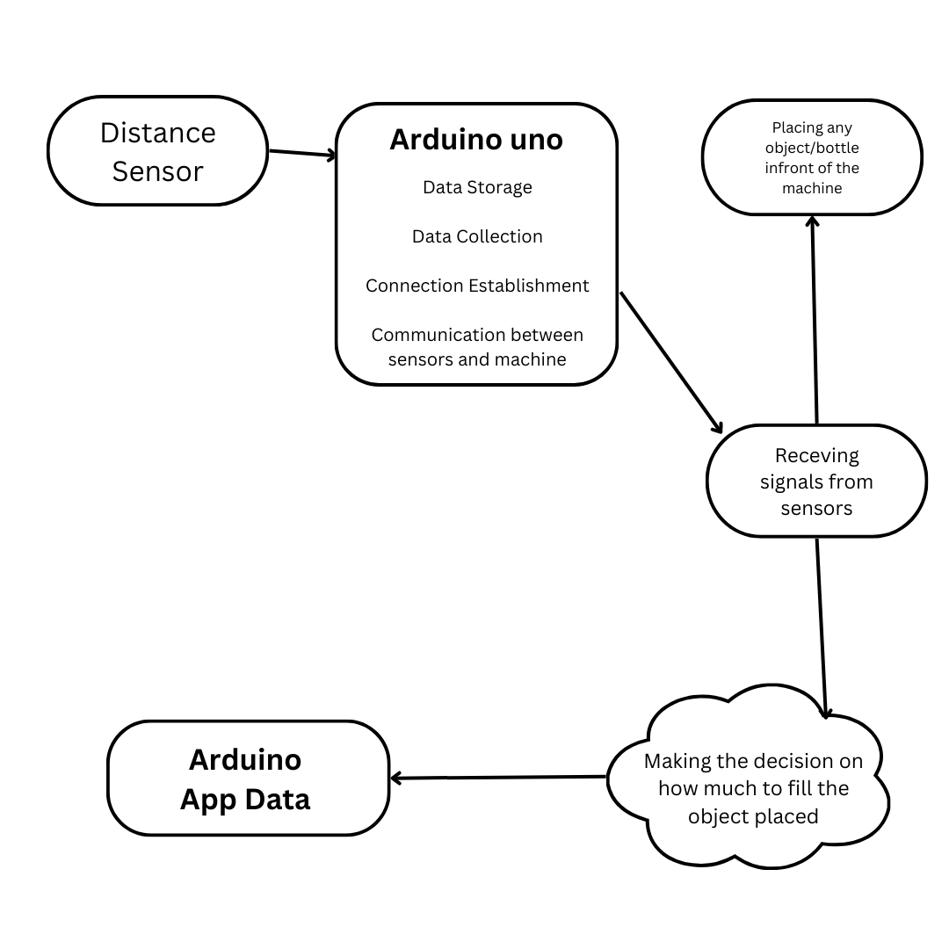

Fig: work flow of automatic bottle filling machine

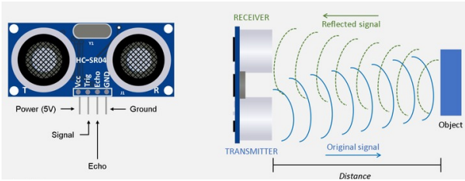

Fig : explanation of working distance sensor

4. Automatic Bottle Filling Machine

The automatic Bottle Filling Machine uses two distance sensors and one actuator having aims not only to sense but also to measure the dimensions of the object in front of the machine using Smart Sensors and then send a Sensor-Request to fill the liquid up to that proportion. The measurement of where the object is placed and then moving for further process is done by ultrasonic unit parts. This consists of the transmitter part of ultrasonic module units. The distance from any object is calculated from D = S x T The ultrasonic module is initiated with a pulse of 10 us.[2].after measuring the distance now the second sensor is used to measure the height of the object/bottle present as a component. It can be used over a wide temperature range. Height measurement can also be considered as another application.[3].

We use the ultrasonic distance sensor to detect and measure the distance of the object as it helps in showing the accuracy and any error with the help of principal called as ultrasonic sensor. With the help of the frequency of the sensor [1]. There are so many ways in which the motion of objects can be identified, the project includes the automatic flowing of water or any other liquid when comes in a predefined space nearer to the machine. The paper which tells us about the motion of the object was shown in this paper where it detects the movement of the objects and displays the results on the screen. [4].We used the method of an ultrasonic sensor for distance measuring for example detecting the distance of an object how far or close it has been placed and giving information where the object is in live location. [5]

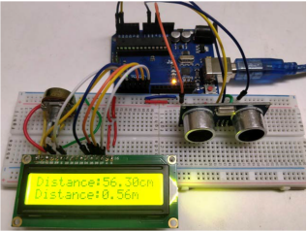

Fig.3 Implementation

5. Conclusion

Curated and Implemented an Automatic Filling System with a few changes in the currently present system to make it more efficient and resourceful with less wastage.

6. Future Enhancement

How we can make the working of this project more efficient. We can try to make our project work with a single sensor without compromising on the functionalities. We will not only try to Reduce the cost but also reduce the space the machine takes. We will try to bring more sfeatures to the project (not only for a few liquids). Try to cut down the time duration to make it work faster. We will also try to make accessibility a little bit easier. We will also try to make the machine work remotely i.e. try to make it work from any mobile device through automation.

7. References

1. Wang, S., Liu, Q., Chen, S., & Xue, Y. *Design and application of distance measure ultrasonic sensor*. SpringerLink. Retrieved 2020, from https://link.springer.com/chapter/10.1007/978-3-642-31528-2_18

2.

1. Team, T. A. (n.d.). Getting started with the web editor: Arduino documentation. Arduino Documentation | Arduino Documentation. Retrieved November 26, 2022, from https://docs.arduino.cc/arduino-cloud/getting-started/getting-started-web-editor

2. Arduino ultrasonic distance sensor - javatpoint. www.javatpoint.com. (n.d.). Retrieved November 26, 2022, from https://www.javatpoint.com/arduino-ultrasonic-distance-sensor

3. Distance measurement using ultrasonic sensor and Arduino. Distance Measurement using Arduino Ultrasonic Sensor: Code & Circuit Diagram. (n.d.). Retrieved November 26, 2022, from https://circuitdigest.com/microcontroller-projects/arduino-ultrasonic-sensor-based-dist ance-measurement

4. System. (2010, August 26). Pseudo code clarification. Arduino Forum. Retrieved November 26, 2022, from https://forum.arduino.cc/t/pseudo-code-clarification/44717/6

5. Distance measurement using Arduino ultrasonic sensor. Arduino Project Hub. (n.d.). Retrieved November 26, 2022, from

https://create.arduino.cc/projecthub/Junezriyaz/distance-measurement-using-arduinoultrasonic-sensor-409169